

|  |  |  |  |  |  |  |  |  |
| --- | --- | --- | --- | --- | --- | --- | --- | --- |
|  | | | | | | | | |
|  | | BLAZE FINDER | | | | |  | |
|  |  | | | | | | |  |
|  | | | |  |  | | | |
|  | | | | PREPARED BY:   GAURAV (CONTENT CREATER) BTC35114  JATIN (ALORITHUM WRITER) BTC35120  KARTIK (CODER) BTC35125  PUNIT KUMAR(CODER)BTC35150 |  | | | |
|  | | | | 2022-2023—BTECH CSE—Submitted to Dr. Aanchal Assistant professor |  | | | |
|  | | |  | | |  | | |



|  |  |  |  |  |  |  |  |  |
| --- | --- | --- | --- | --- | --- | --- | --- | --- |
|  |  | | |  |  | | |  |
|  | INSTRUCTIONS | | | | | | |  |
|  |  | | |  |  | | |  |
|  |  | |  | | |  | |  |
|  |  |  | Stubble burning is the intentional burning or setting on fire of crop residue to remove them from the field in order to sow the next crop.   * In these areas, it begins around October, the same time at which the southwest monsoon withdraws. * Section 188 of the Indian Penal code makes stubble burning a crime. Additionally, it was notified as an offence under the Air (Prevention and Control of Pollution) Act, 1981. | | |  |  |  |
| Barn fire breaks out at WNY dairy farm - YouTube | | | | |
|  |  |  |  |
|  |  |



|  |  |  |  |  |  |  |  |  |
| --- | --- | --- | --- | --- | --- | --- | --- | --- |
|  | |  |  | | |  |  | |
|  | | THE PROCESS | | | | |  | |
|  | |  |  | | |  |  | |
|  | How we reach here The code you made is for identifying stable burning in a set of images and saving the results in two separate datasets. Here's a breakdown of the code:  1. The code imports the necessary libraries: `cv2` for computer vision operations, `numpy` for numerical computations, and `pandas` for working with datasets.  2. The function `identify_stable_burning` is defined, which takes two arguments: `image_paths` (a list of image file paths) and `threshold_area` (a value used to filter contours based on their area).  3. Inside the function, two empty DataFrames (`dataset1` and `dataset2`) are created to store the results of the analysis.  4. The function loops through each image path provided in `image_paths`.  5. For each image, the code loads the image, converts it to grayscale, and applies thresholding to create a binary image.  6. Contours are then extracted from the binary image using the `cv2.findContours` function.  7. The extracted contours are filtered based on their area using a list comprehension.  8. The filtered contours are drawn on the original image using the `cv2.drawContours` function.  9. The image is classified as either having stable burning or not based on the number of filtered contours.  10. The classified image path and label are added as a new row to the respective dataset (`dataset1` or `dataset2`).  11. The result is displayed using `cv2.imshow` and the window is closed after a key is pressed.  12. After processing all the images, the two datasets are saved to CSV files using `dataset1.to_csv` and `dataset2.to_csv`.  13. The code then loads the saved datasets from the CSV files using `pd.read_csv`.  14. The data in `dataset1` and `dataset2` are accessed and printed using `print(dataset1.head())` and `print(dataset2.head())`.  Overall, this code analyzes a set of images, identifies stable burning based on contour area, and saves the results in two datasets. | | | | | | |  |
|  | SOLUTION OF TIS BURNING | | |  |  | | |  |
|  | * Incentivize farmers for not burning the stubble and provide economic value for the crop residue. The stubble can be converted into fodder or organic fertilizer or fuel. The government should also subsidize or incentivize the industries that are engaged in converting stubble into economically viable products. | | |  | * Efforts should be made to improve the combine harvester that farmers use to harvest the crop. The current machine used leaves behind a huge residue. Improvement should be made in the technology used in such machines so that minimal residue is left behind. | | |  |

|  |  |  |  |  |  |  |
| --- | --- | --- | --- | --- | --- | --- |
|  |  | | | | |  |
|  | |  |  |  |  | |
|  |  | | | | |  |

CODE FOR IMAGE PROCESSING

import cv2

import numpy as np

import pandas as pd

def identify_stable_burning(image_paths, threshold_area, group_size):

# Create DataFrames for datasets

dataset1 = pd.DataFrame(columns=['Image', 'Label']) # Dataset for stable burning

dataset2 = pd.DataFrame(columns=['Image', 'Label']) # Dataset for no stable burning

# Counter for grouping images

counter = 0

for image_path in image_paths:

# Load image

img = cv2.imread(image_path)

# Convert to grayscale

gray = cv2.cvtColor(img, cv2.COLOR_BGR2GRAY)

# Threshold image

ret, thresh = cv2.threshold(gray, 0, 255, cv2.THRESH_BINARY | cv2.THRESH_OTSU)

# Find contours

contours, _ = cv2.findContours(thresh, cv2.RETR_EXTERNAL, cv2.CHAIN_APPROX_SIMPLE)

# Filter contours based on area or other criteria

filtered_contours = [contour for contour in contours if cv2.contourArea(contour) > threshold_area]

# Draw contours on the original image

result = img.copy()

cv2.drawContours(result, filtered_contours, -1, (0, 255, 0), 2)

# Classify and save the image in the respective dataset

if len(filtered_contours) > 1:

print(f"Stable burning detected in {image_path}")

dataset1.loc[len(dataset1)] = [image_path, "Stable Burning"]

else:

print(f"No stable burning detected in {image_path}")

dataset2.loc[len(dataset2)] = [image_path, "No Stable Burning"]

# Increment counter

counter += 1

# Display the images in groups

if counter % group_size == 0 or counter == len(image_paths):

cv2.imshow('Stable Burning', result)

cv2.waitKey(0)

cv2.destroyAllWindows()

dataset1.to_csv(r'D:\Users\91805\Documents\Punit Docs\semster 2\project image processsing\dataset1.csv', index=False)

dataset2.to_csv(r'D:\Users\91805\Documents\Punit Docs\semster 2\project image processsing\dataset2.csv', index=False)

# Set the list of image paths

image_paths = [

"D:\\Users\\91805\\Documents\\Punit Docs\\semster 2\\project image processsing\\burnedfield1.jpg",

"D:\\Users\\91805\\Documents\\Punit Docs\\semster 2\\project image processsing\\burnedfield2.jpg",

"D:\\Users\\91805\\Documents\\Punit Docs\\semster 2\\project image processsing\\burnedfield3.jpg",

"D:\\Users\\91805\\Documents\\Punit Docs\\semster 2\\project image processsing\\burnedfield4.jpg",

"D:\\Users\\91805\\Documents\\Punit Docs\\semster 2\\project image processsing\\burnedfield5.jpg",

"D:\\Users\\91805\\Documents\\Punit Docs\\semster 2\\project image processsing\\burnedfield6.jpg",

"D:\\Users\\91805\\Documents\\Punit Docs\\semster 2\\project image processsing\\burnedfield7.jpg",

"D:\\Users\\91805\\Documents\\Punit Docs\\semster 2\\project image processsing\\burnedfield8.jpg",

"D:\\Users\\91805\\Documents\\Punit Docs\\semster 2\\project image processsing\\field.jpg",

"D:\\Users\\91805\\Documents\\Punit Docs\\semster 2\\project image processsing\\field1.jpg",

"D:\\Users\\91805\\Documents\\Punit Docs\\semster 2\\project image processsing\\field2.jpg",

"D:\\Users\\91805\\Documents\\Punit Docs\\semster 2\\project image processsing\\field3.jpg",

"D:\\Users\\91805\\Documents\\Punit Docs\\semster 2\\project image processsing\\field4.jpg",

"D:\\Users\\91805\\Documents\\Punit Docs\\semster 2\\project image processsing\\field5.jpg",

"D:\\Users\\91805\\Documents\\Punit Docs\\semster 2\\project image processsing\\field6.jpg",

]

# Set the threshold area for filtering contours

threshold_area = 1000

# Set the group size for displaying images

group_size = 3

# Call the function to identify stable burning and display images in groups

identify_stable_burning(image_paths, threshold_area, group_size)

dataset1 = pd.read_csv(r'D:\Users\91805\Documents\Punit Docs\semster 2\project image processsing\dataset1.csv')

dataset2 = pd.read_csv(r'D:\Users\91805\Documents\Punit Docs\semster 2\project image processsing\dataset2.csv')

# Access and print the data in dataset1

print("Dataset 1:")

print(dataset1.head())

# Access and print the data in dataset2

print("Dataset 2:")

print(dataset2.head())

PROCESSED IMAGE

Stubble Burning Identified No Stubble burning

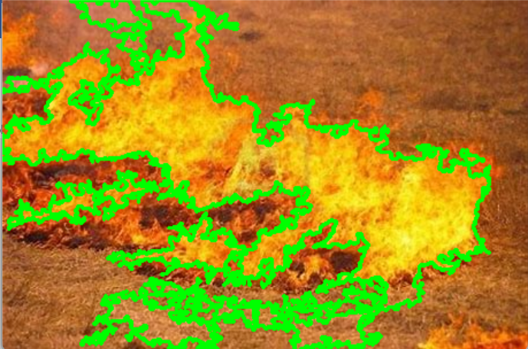 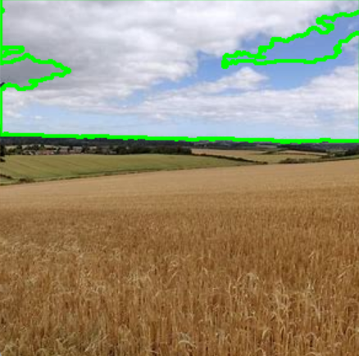

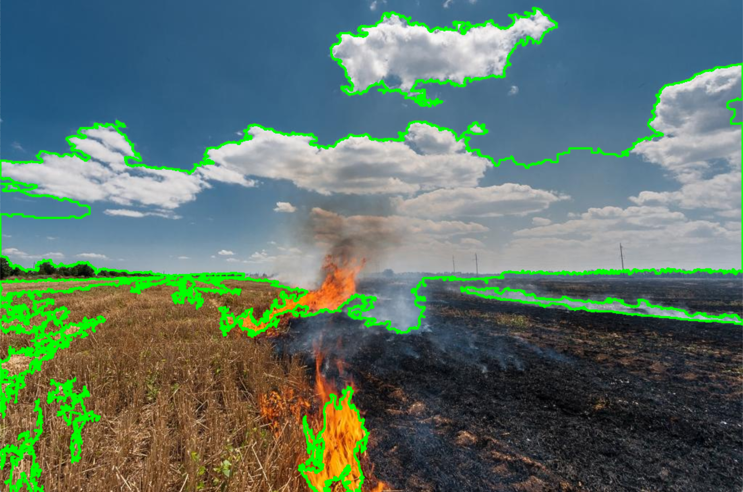 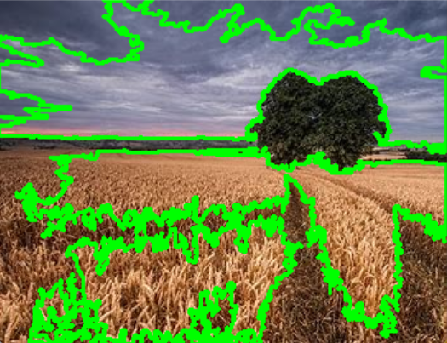

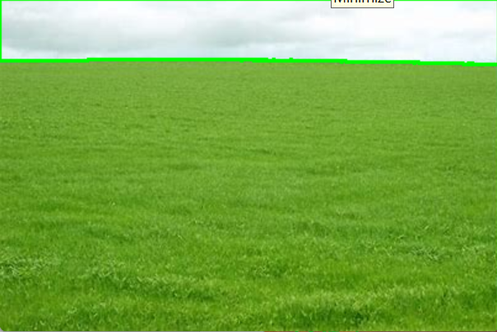

LIBRARAY USED :

* 1. OPEN CV (for image processing)
  2. NUMPY (numerical computation)
  3. PANADS (for creating DataFrames for datasets)

HOW IT WORKED

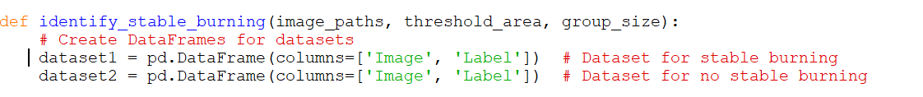

Here we created datasets where our final classified result is going to be stored dataset 1 store the burned field while Dataset 2 stored image which are safe

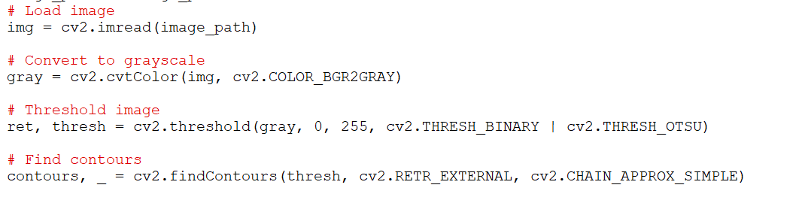

Here we are uploading our image from form our set using for loop and then we converted it into

Gray Image using . cvt Color using cv2.BGR2GRAY.

After converting it using cv2.threshold we converted into threshold image using cv2.THRESH_BINARY so that we can draw contour in our burned field ,After that we draw contours .

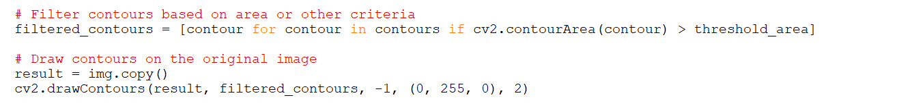

Here we than filter our Noise by setting Threshold Area. Noise like shadow, trees, other Flora and fauna . Here we set Threshold area as 1000 pixels, and Draw our contours

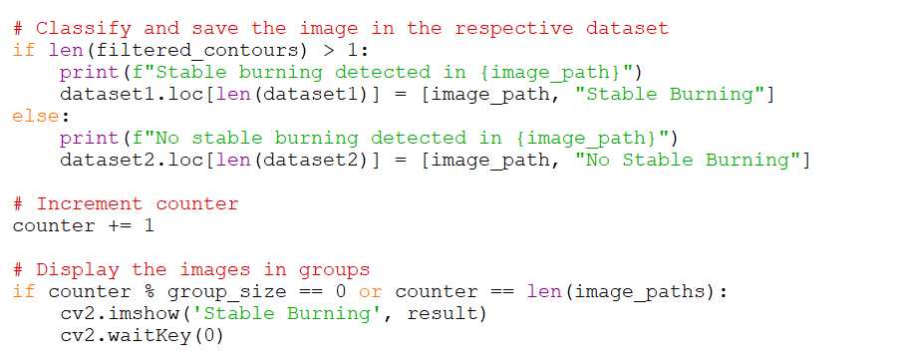

Finally we classified the image into 2 subsets and put the in their respective Datasets.

And displayed our image in group of 3.